Create a file with .txt extension (/home/demo.txt). Change the permission set of that file, so that any user can read it, group can read/write & owner can read/write/execute it.
root@ubuntu-VirtualBox:/home# ls
ubuntu
root@ubuntu-VirtualBox:/home# touch /home/demo.txt
root@ubuntu-VirtualBox:/home# ls
demo.txt ubuntu
root@ubuntu-VirtualBox:/home# ls -l /home/demo.txt
-rw-r--r-- 1 root root 0 Jul 24 20:23 /home/demo.txt
root@ubuntu-VirtualBox:/home# chmod 764 /home/demo.txt
root@ubuntu-VirtualBox:/home# ls -l /home/demo.txt
-rwxrw-r-- 1 root root 0 Jul 24 20:23 /home/demo.txt
root@ubuntu-VirtualBox:/home#
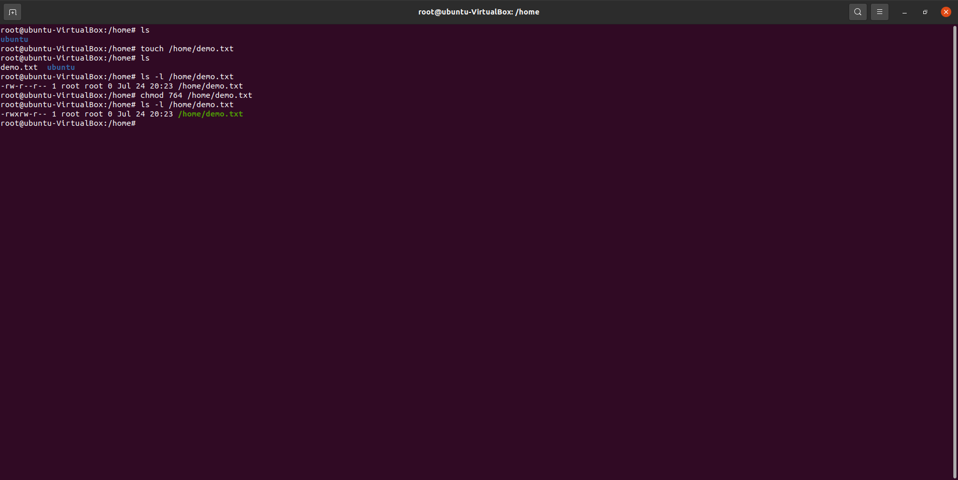
Screenshot:

